PHP Code

**AuthController.php**

<?php

namespace App\Http\Controllers\authentication;

use Illuminate\Http\Request;

use App\Http\Controllers\Controller;

use Illuminate\Support\Facades\DB;

use Symfony\Component\HttpFoundation\Response;

use Illuminate\Http\RedirectResponse;

class authController extends Controller

{

//login

public function viewLoginPage(){

return view('loginpage');

}

public function userLogin(Request $req){

$username = $req -> username;

$password = $req -> password;

$users = DB::select('select * from member

where username = "'.$username.'"

and password = "'.$password.

'" limit 0, 1;');

if(count($users) >0)

{

$result = $users;

return response() -> json($result);

}

else

{

$result= false;

return response()-> json($result);

}

}

//login end

//register

public function viewSignUpPage(){

return view('signuppage');

}

public function userRegister(Request $req){

$username = $req -> username;

$password = $req -> password;

$fullname = $req -> fullname;

$phoneno = $req -> phoneno;

DB::insert('insert into member(username, password, fullname, phoneno)

values("'.$username.'","'.$password.'","'.$fullname.'","'.$phoneno.'");');

return 'done register';

}

//register end*/

public function checkMemberType($member_type){

if($member_type === "ADMIN"){

return true;

}

else{

return false;

}

}

}

**HomeController.php**

<?php

namespace App\Http\Controllers;

use Illuminate\Http\Request;

use App\Http\Controllers\Controller;

use Illuminate\Support\Facades\DB;

use Illuminate\Support\Facades\Redirect;

use Illuminate\Support\Collection;

use Illuminate\Support\Facades\Input;

class HomeController extends Controller

{

public function viewHomePage()

{

return view('homepage');

}

public function listMovies(){

$movies = DB::select('select m.*, group_concat(distinct g.genre_name order by g.genre_name desc separator ", ") as genres

from movie m

inner join genre_assign ga on m.movie_pk = ga.movie_fk

inner join genre g on ga.genre_fk = g.genre_pk

group by m.movie_pk;');

return Response()-> json($movies);

}

public function searchMovies(Request $req){

$search_txt = $req-> search_txt;

$movie_genre = $req-> movie_genre;

$movie_year = $req-> movie_year;

$movies = DB::select('select m.*, GROUP_CONCAT(DISTINCT g.genre_name ORDER BY g.genre_name DESC SEPARATOR ", ") AS genres_name,

GROUP_CONCAT(DISTINCT g.genre_pk ORDER BY g.genre_pk DESC SEPARATOR ", ") AS genres_pk

FROM movie m

INNER JOIN genre_assign ga ON m.movie_pk = ga.movie_fk

INNER JOIN genre g ON ga.genre_fk = g.genre_pk

WHERE g.genre_pk LIKE "'. $movie_genre .'"

AND m.year LIKE "'. $movie_year .'"

AND m.title LIKE "%'. $search_txt .'%"

GROUP BY m.movie_pk;');

return Response()-> json($movies);

}

public function viewMovieDetailPage(Request $req){

$movie_pk = $req -> movie_pk;

//$movie_detail = DB::table('movie')->where('movie_pk', $movie_pk)->first();

$movie_detail = DB::select('select m.*, group_concat(distinct g.genre_name order by g.genre_name desc separator ", ") as genres

from movie m

inner join genre_assign ga on m.movie_pk = ga.movie_fk

inner join genre g on ga.genre_fk = g.genre_pk

where movie_pk ='. $movie_pk .';');

return view ('moviedetail')->with('movie_detail', $movie_detail);

}

public function addMovie(){

$movie_name = Input::get("movieNameTxt");

$movie_year = Input::get("yearTxt");

$movie_synopsis = Input::get("synopsisTxt");

if(Input::hasFile('image')){

$file = Input::file('image');

$file-> move('movieImageUpload', $file-> getClientOriginalName());

$movie_image_name = $file -> getClientOriginalName();

}

DB::insert('insert into movie(title, YEAR, synopsis, image)

VALUES("'. $movie_name .'","'. $movie_year . '","' . $movie_synopsis . '","'. $movie_image_name . '");');

$movie_pk_array = DB::select('select LAST_INSERT_ID() as movie_pk;');

$movie_pk = $movie_pk_array[0]->movie_pk;

foreach($_POST['check_list'] as $checkbox_value){

DB::insert('insert into genre_assign(movie_fk, genre_fk)

VALUES('. $movie_pk .','. $checkbox_value .')');

}

echo "<script>

alert('Movie Added successfully!');

window.location.href = '\homepage';

</script>";

}

public function editMovie(){

$movie_pk = Input::get('movie_pk');

$movie_name = Input::get("movieNameTxt");

$movie_year = Input::get("yearTxt");

$movie_synopsis = Input::get("synopsisTxt");

$movie_image_name = Input::get("img_name");

if(Input::hasFile('image')){

$file = Input::file('image');

$file-> move('movieImageUpload', $file-> getClientOriginalName());

$movie_image_name = $file -> getClientOriginalName();

}

DB::select('update movie

set title = "'. $movie_name .'", year="'. $movie_year . '", synopsis="' . $movie_synopsis . '", image="'. $movie_image_name . '"

where movie_pk ='. $movie_pk .';');

DB::delete('delete from genre_assign

where movie_fk = '. $movie_pk . ';');

foreach($_POST['check_list'] as $checkbox_value){

DB::insert('insert into genre_assign(movie_fk, genre_fk)

VALUES('. $movie_pk .','. $checkbox_value .')');

}

echo "<script>alert('Movie Edited successfully!');

window.location.href= '/movieDetail?movie_pk=' +". $movie_pk ."

</script>";

}

public function deleteMovie(){

$movie_pk = Input::get("movie_pk");

DB::delete('delete from movie

where movie_pk = '. $movie_pk . ';');

echo "<script>alert('Movie Deleted!');

window.location.href = '\homepage';

</script>";

}

}

**Route: Web.php**

//homepage

Route::get('/homepage', 'HomeController@viewHomePage');

//list movies(homepage)

Route::get('/listMovies', 'HomeController@listMovies');

Route::get('/searchMovies', 'Homecontroller@searchMovies');

Route::get('/movieDetail', 'HomeController@viewMovieDetailPage');

//MOVIE MANAGEMENT

Route::post('/addMovie', 'HomeController@addMovie');

Route::post('/editMovie', 'HomeController@editMovie');

Route::post('/deleteMovie', 'HomeController@deleteMovie');

//login

Route::get('/loginpage', 'Authentication\authController@viewLoginPage');

Route::get('/login', 'Authentication\authController@userLogin');

//register

Route::get('/signuppage','Authentication\authController@viewSignUpPage');

Route::get('/register', 'Authentication\authController@userRegister');

JavaScript Code(Input Validation)

**Validate Add Movie Form**

function validateForm(){

var $img_name = document.getElementById("image").value;

var $movie_name = document.getElementById("movieNameTxt").value;

var $synopsis = document.getElementById("synopsisTxt").value;

var checkboxes = document.getElementsByClassName("checkboxes");

var checkboxes_checked =0;

var bool_img_name, bool_movie_name, bool_synopsis, bool_select_genre;

var total_bool_valid = 0;

for (var i = 0; i < checkboxes.length; i++) {

if (checkboxes[i].checked) {

checkboxes_checked++;

}

}

if($img_name != null && $img_name != ''){

bool_img_name = 1;

document.getElementById("required-label-img-name").style.display = "none";

}

else{

bool_img_name = 0;

document.getElementById("required-label-img-name").style.display = "block";

}

if($movie_name != null && $movie_name != ''){

bool_movie_name = 1;

document.getElementById("required-label-movie-name").style.display = "none";

}

else{

bool_movie_name = 0;

document.getElementById("required-label-movie-name").style.display = "block";

}

if($synopsis != null && $synopsis != ''){

bool_synopsis = 1;

document.getElementById("required-label-synopsis").style.display = "none";

}

else{

bool_synopsis = 0;

document.getElementById("required-label-synopsis").style.display = "block";

}

if(checkboxes_checked > 1){

bool_select_genre = 1;

document.getElementById("required-label-genre").style.display = "none";

}

else{

bool_select_genre = 0;

document.getElementById("required-label-genre").style.display = "block";

}

total_bool_valid = bool_img_name + bool_movie_name + bool_synopsis + bool_select_genre;

if(total_bool_valid == 4){

return true;

}

}

**Validate Edit Movie Form**

function validateForm(){

var $img_name = document.getElementById("image").value;

var $movie_name = document.getElementById("movieNameTxt").value;

var $synopsis = document.getElementById("synopsisTxt").value;

var checkboxes = document.getElementsByClassName("checkboxes");

var checkboxes_checked =0;

var bool_movie_name, bool_synopsis, bool_select_genre;

var total_bool_valid = 0;

for (var i = 0; i < checkboxes.length; i++) {

if (checkboxes[i].checked) {

checkboxes_checked++;

}

}

if($movie_name != null && $movie_name != ''){

bool_movie_name = 1;

document.getElementById("required-label-movie-name").style.display = "none";

}

else{

bool_movie_name = 0;

document.getElementById("required-label-movie-name").style.display = "block";

}

if($synopsis != null && $synopsis != ''){

bool_synopsis = 1;

document.getElementById("required-label-synopsis").style.display = "none";

}

else{

bool_synopsis = 0;

document.getElementById("required-label-synopsis").style.display = "block";

}

if(checkboxes_checked > 1){

bool_select_genre = 1;

document.getElementById("required-label-genre").style.display = "none";

}

else{

bool_select_genre = 0;

document.getElementById("required-label-genre").style.display = "block";

}

total_bool_valid = bool_movie_name + bool_synopsis + bool_select_genre;

if(total_bool_valid == 3){

return true;

}

}

**Sample Outputs(User Manual)**url : /homepage

comment: Any user can view this page.

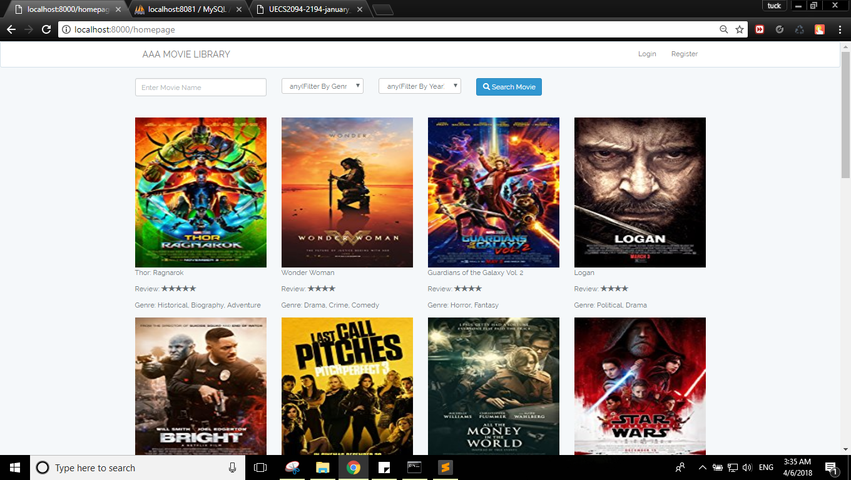

url : /loginpage

comment: Login button in nav bar is clicked.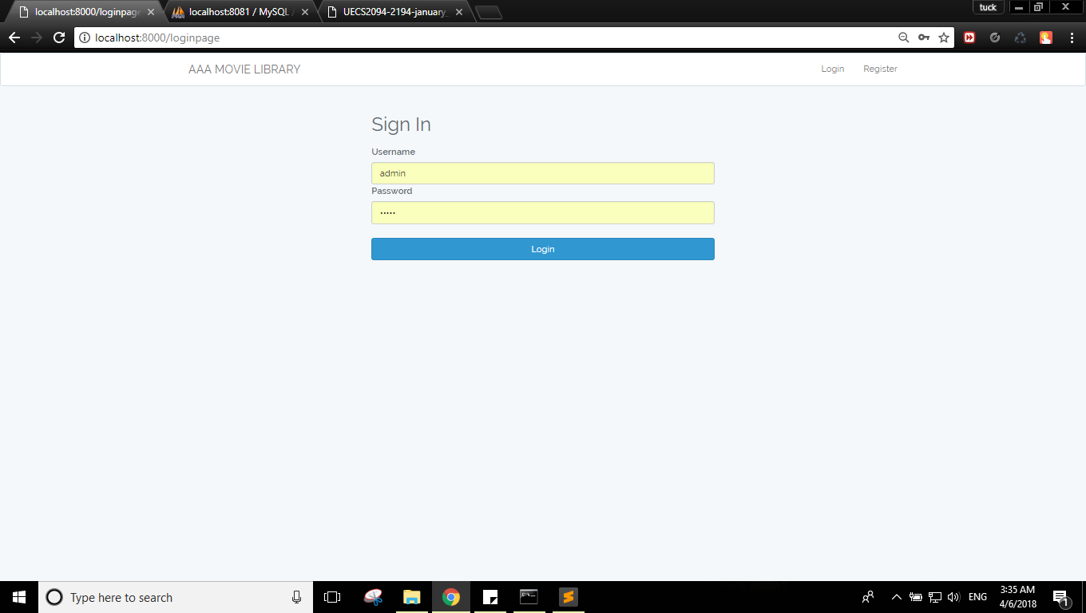

url : /signuppage

comment: This is register page, but I assume all member type is ADMIN to create an new account as admin.

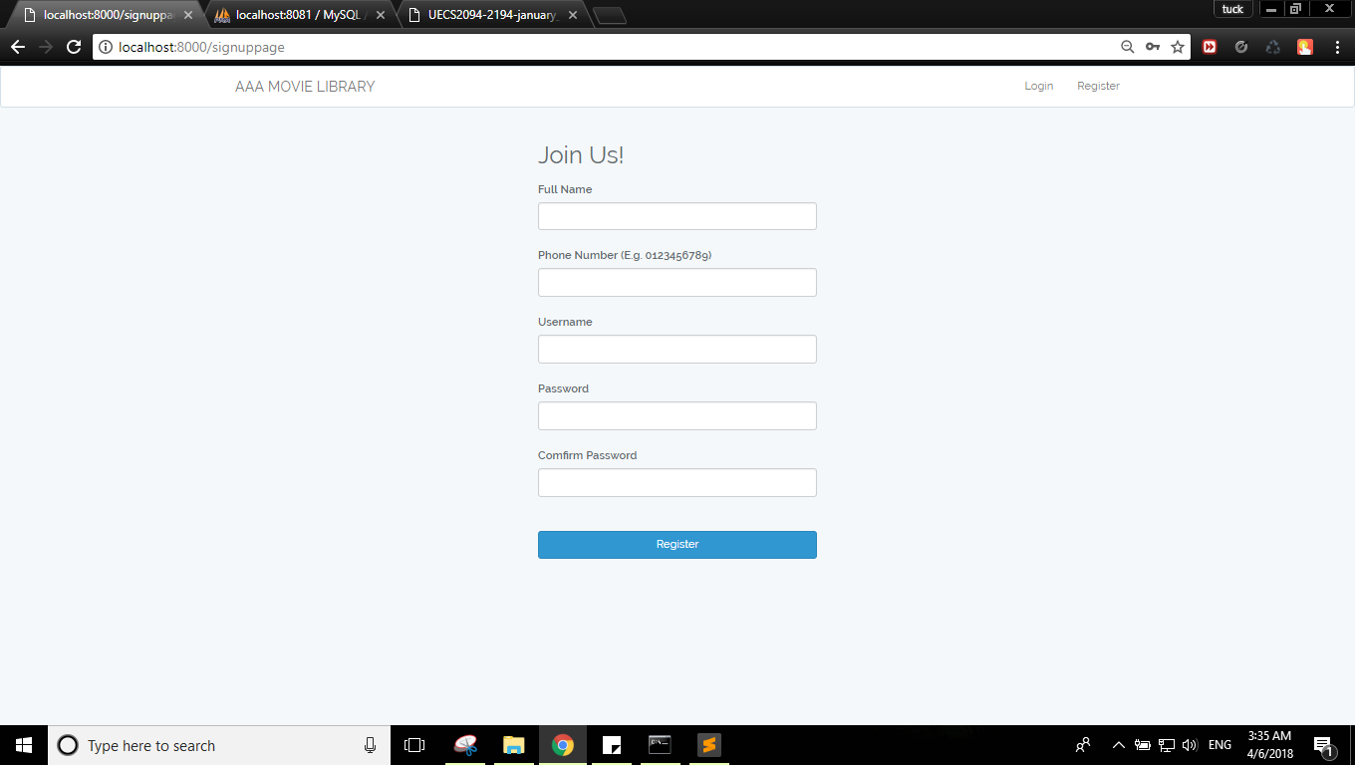

[url: /loginpage](url:/loginpage)

comment: Password is incorrect.

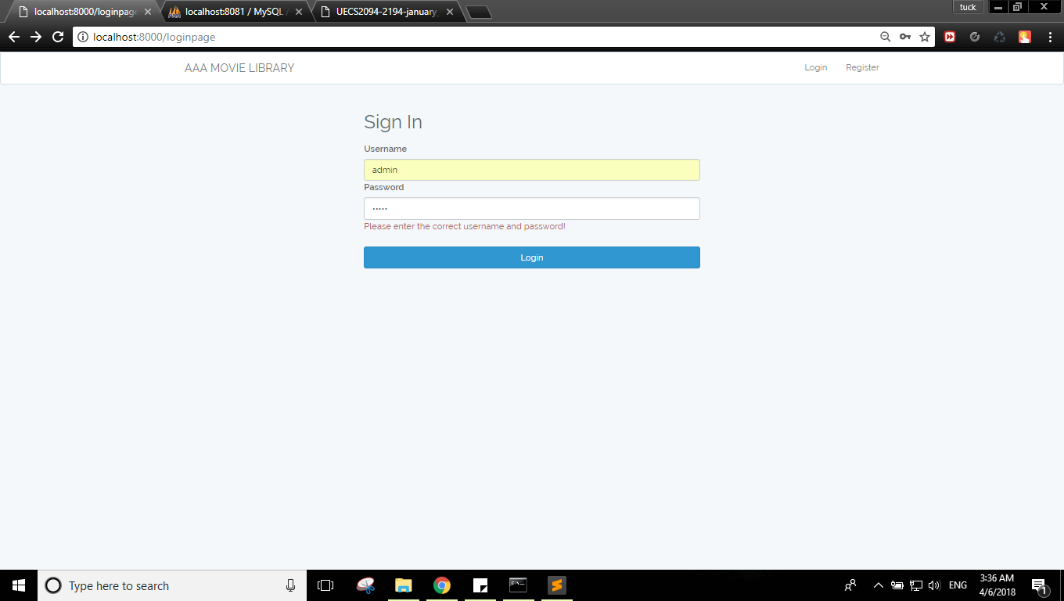

url: /signuppage

comment: Input validation for register.

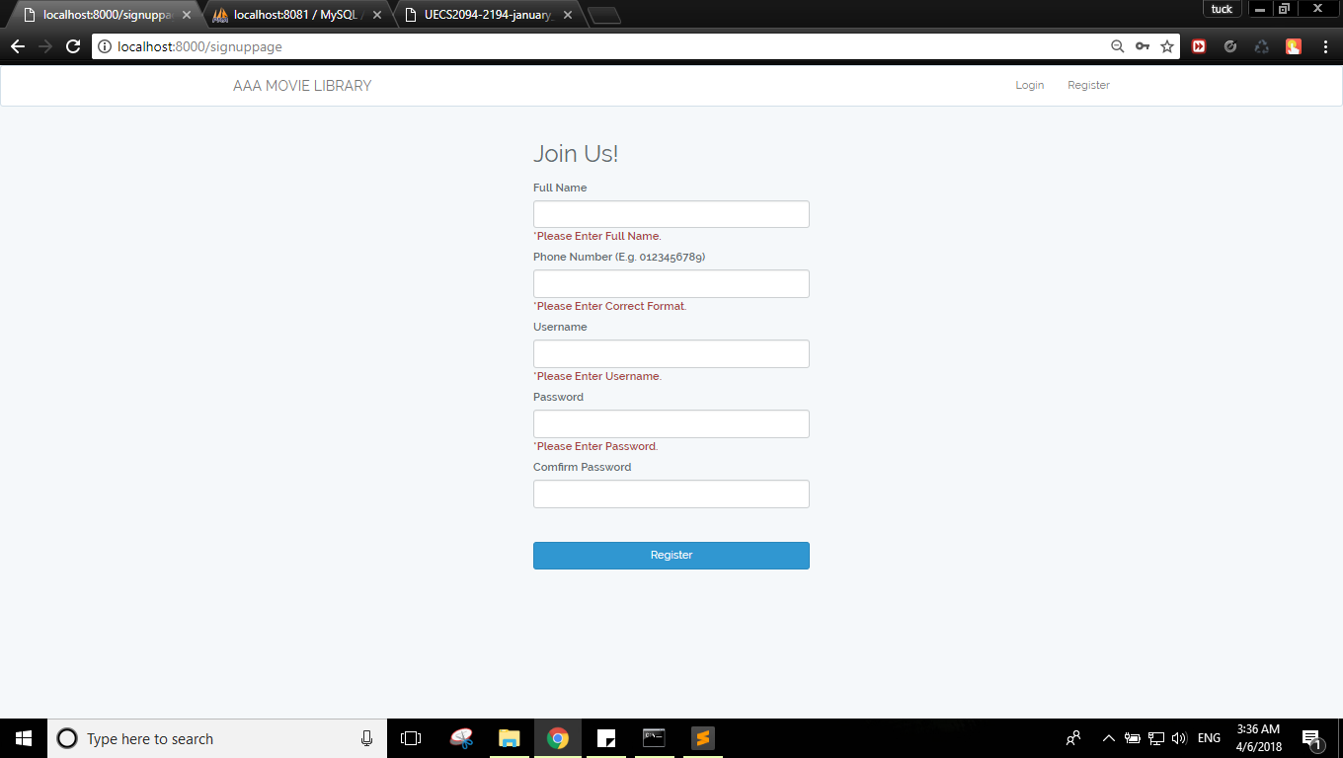

url: /homepage

comment: this page is after user log into the system. Admin add movie function appears.

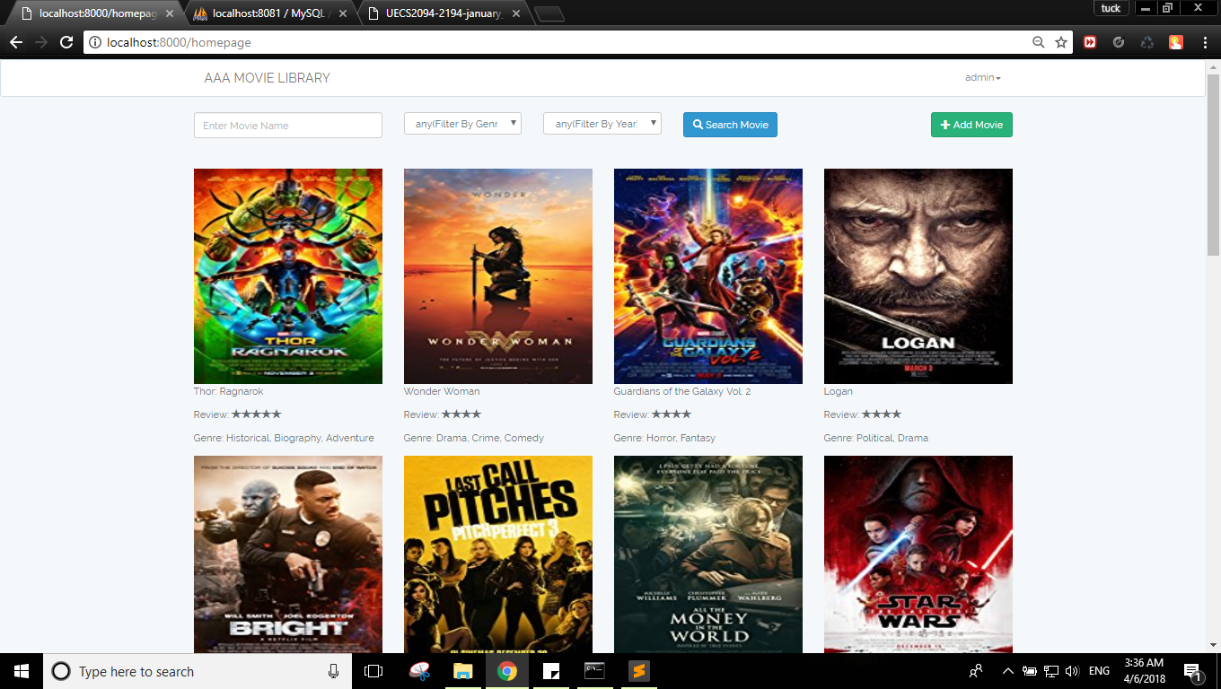

<url:/homepage>

comment: after add movie clicked. The form shows the input validation before we can submit the form.

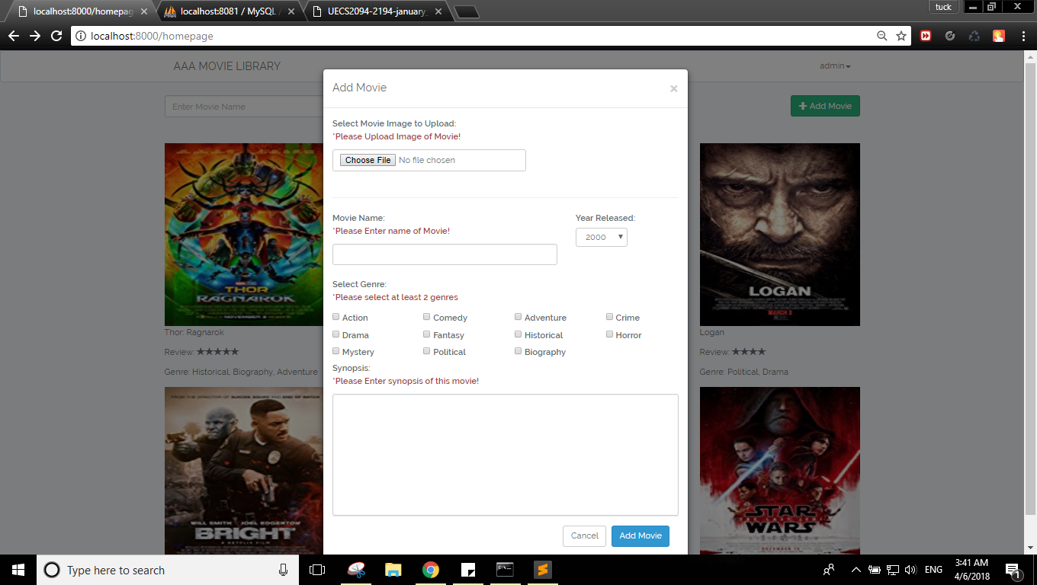

[url:/](url:/homepage)movieDetail

comment: This is client site showing movie details.

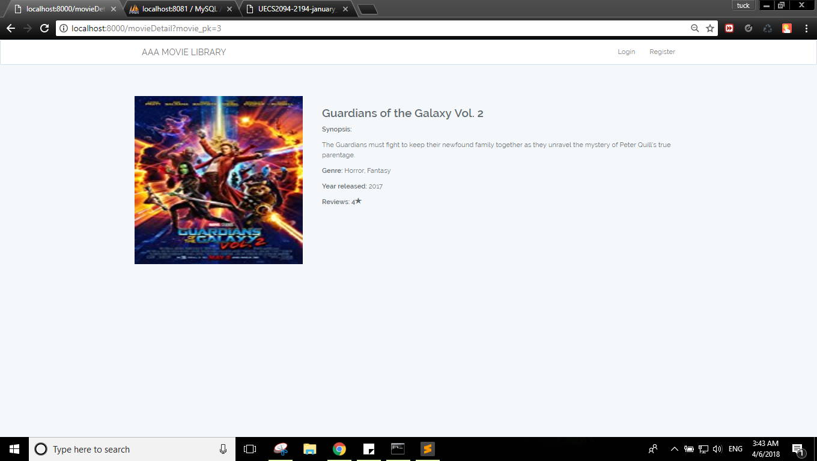

url: /movieDetail

comment: This is admin site showing the details, edit and delete function.

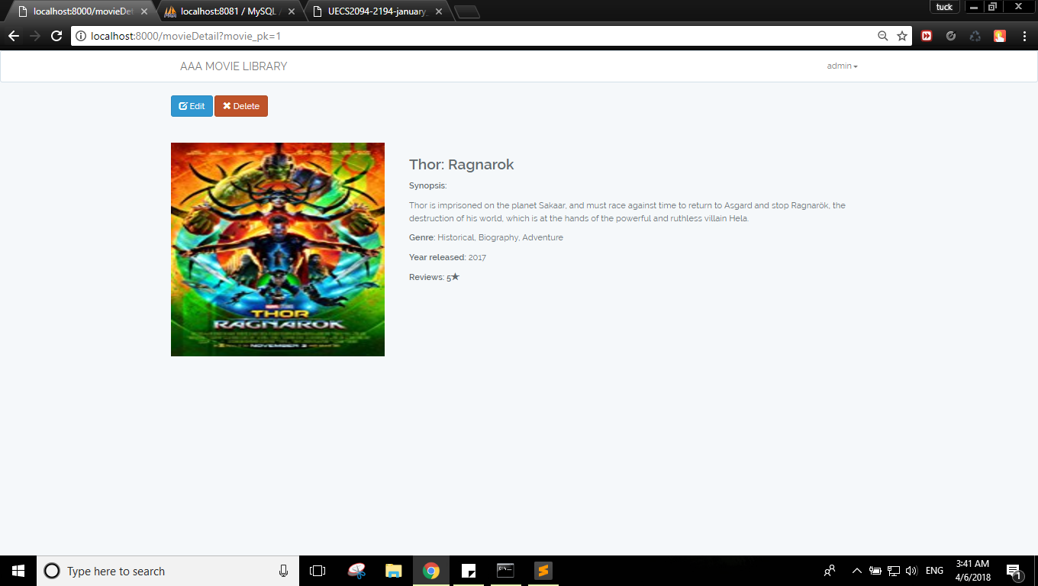

<url:/movieDetail>

comment: After edit button is clicked. The form shows the input has already preset and there is input validation function as well.

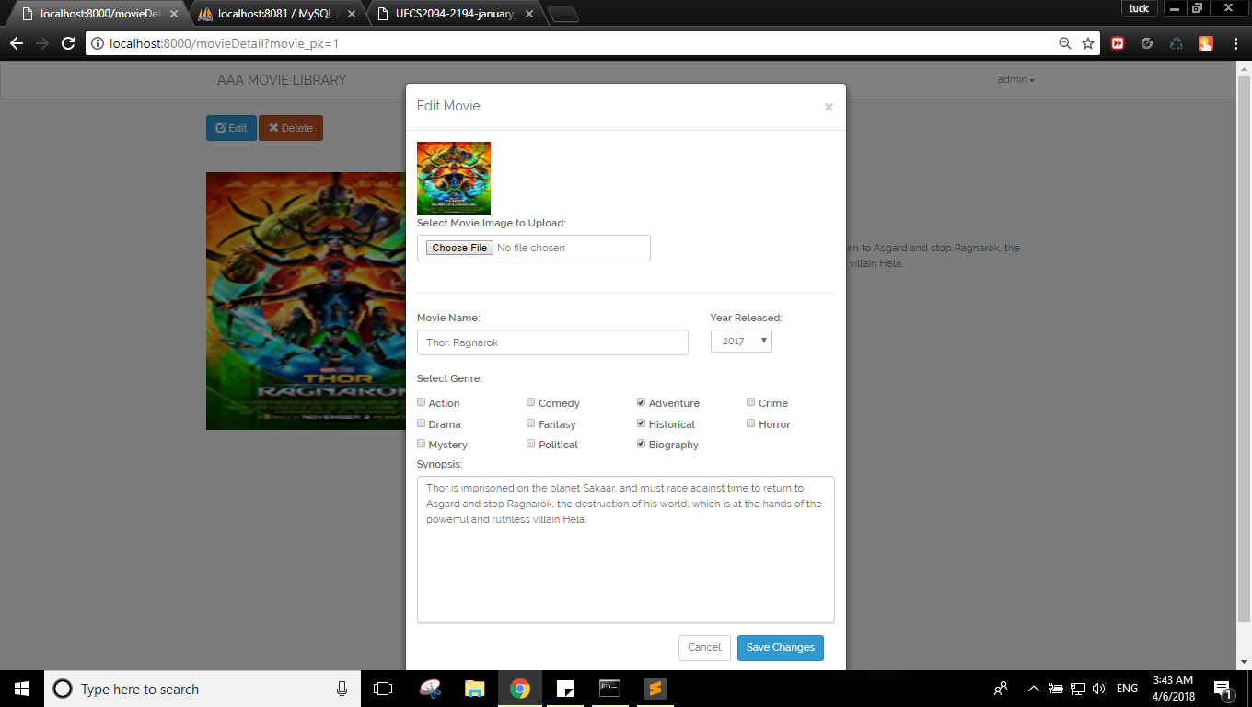

url: /movieDetail

comment: After delete button is clicked. Modal show up to double confirm.

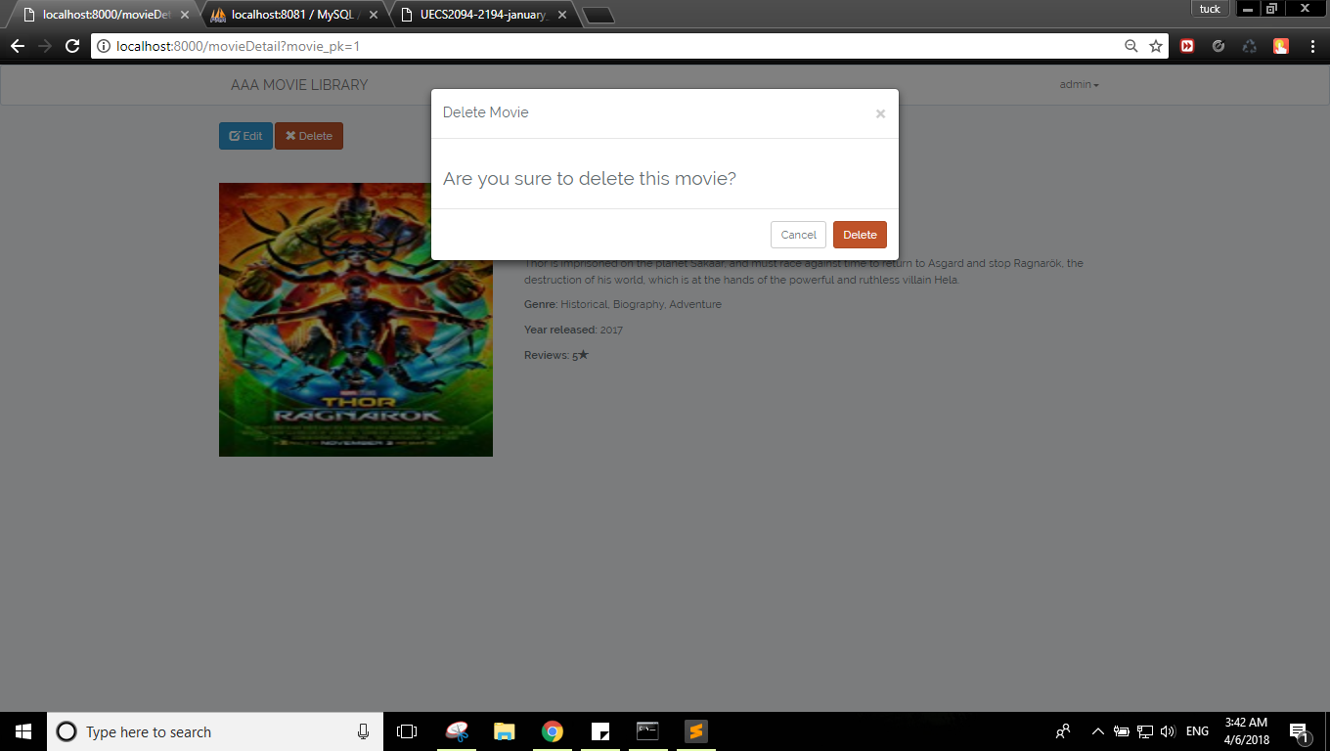

url: /homepage

comment: search button is called. Multiple search input for movie according to year, genre, search keywords, and also arranged in alphabetical order.

